CS-320
Week 7
Daniel Loranger
Summary
To what extent was your approach aligned to the software requirements? Support your claims with specific evidence.
My design approach for all classes and services was specifically aligned with the software requirements. I specifically wrote each instantiator, getter and setter to consider the requirements as written. In most cases, the boundary conditions were hard coded within each relevant function. This would be improvable by removing the hardcoded values and using instead a variable that could propagate through the code during compile time. (Contact.java:L19–L27; Appointment.java:L13–L20; Task.java:L12–L19)

public class Contact {
//behavioral constants
public static final boolean uniqueIDupdatable = false; //disallowed by requirements
private int idLengthMax = 10;
private int firstNameLengthMax = 10;
private int lastNameLengthMax = 10;
private int phoneLength = 10;
private int addressLengthMax = 30;
…
}
In addition to the passing pipeline, I explicitly created checkers to ensure any future code could point to a single checker for each variable to ensure the code had the same checks in place regardless of how the code got into the current workflow. These checkers check against maximum allowed lengths, null and empty responses, and could easily be expanded for other fault conditions that were not provided in the requirements. (Contact.java:L36–L47; Contact.java:L93–L102; Appointment.java:L27–L38; Appointment.java:L51–L58; Task.java:L73–L82)
private boolean checkDescription(String testStr){
if (testStr == null){
throw new IllegalArgumentException("Description cannot be null");
}
if (testStr.length() > descriptionLengthMax){
throw new IllegalArgumentException("Description cannot be longer than " + descriptionLengthMax + " characters");
}
return true;
}

Where relevant, I also used methods to ensure uniqueID always would get the desired target by enforcing a capitalization requirement to ensure AAA, AAa, AaA, etc. would always return the same record. This prevents accidental edits to the wrong ID based on a capitalization error. (Contact.java:L129–L134; Appointment.java:L105–L109; Task.java:L83–L88)
public String getUniqueID() {
return uniqueID.toUpperCase();
}

public void setUniqueID(String uniqueID) {
this.uniqueID = uniqueID.toUpperCase();
}

Defend the overall quality of your JUnit tests. In other words, how do you know your JUnit tests were effective based on the coverage percentage?
The quality of my JUNIT test I believe is very high performing. Having some background in hardware verification (FPGA), I took the mindset of complete code coverage being the goal. The requirements I felt were low at 70% as there could be a number of bugs left hidden in the remaining 30% of untested code. I felt this would be something that would be unacceptable in any reasonable production environment. Rather, I wrote tests for every possible combination, just right, null, empty, oversized, etc. for every getter and setter, and instantiator respectively. (ContactTest.java:L175–L187; ContactTest.java:L337–L350) The results of this resulted in a test coverage of >93%.
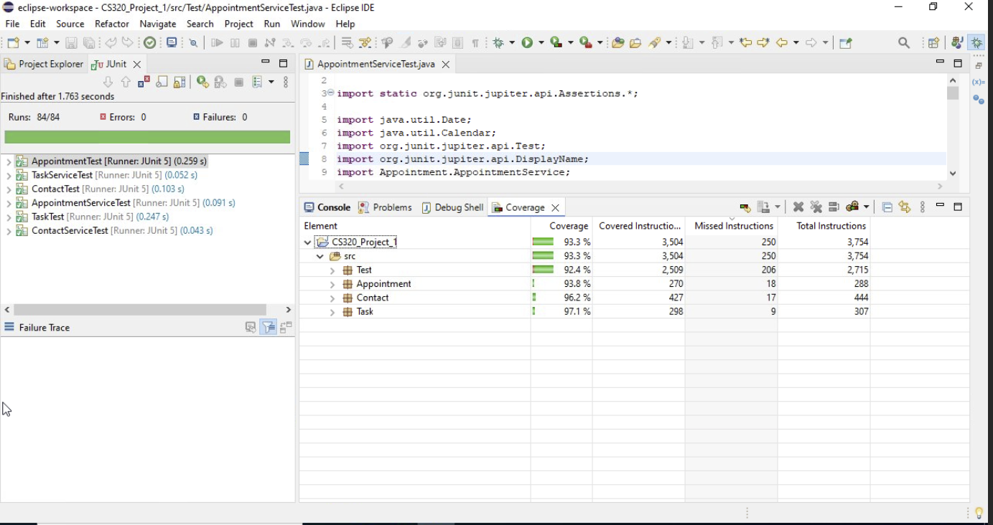
To ensure I handled every possible combination, I utilized AI (ChatGPT) to review the code and look for possible missing test cases, as well as bugs in the tests that could lead to test escapes. It did find some that even as the tester, I had made that would have led to operational code test escapes. This was my solution to having a code review with peers.
In this scenario, I did not consider the efficiency of the code in terms of code execution durations as there were no large transactions or sequences involved that could cause long compute cycles that would be hinderances or cause other poor effects in the system performance. If the code utilized sorting algorithms, then certainly this would have been a concern. Perhaps the search mechanisms could be optimized as in a heavily populated use case the search routines could be very inefficient, and design using a binary search tree would be more appropriate, but this work assumed a database would be used long term and would have appropriate server level searchers and storage mechanisms in place to obviscate this implementation detail.
What were the software testing techniques that you employed in this project? Describe their characteristics using specific details.
Several testing techniques were utilized, including static testing (no running code) including reviewing the implementation requirements to understand the identified ways the code could misbehave such as imputing nulls, empty strings, or excessively long entries. (Contact.java:L36–L47; Appointment.java:L27–L38)
These led directly to specific JUNIT test cases to ensure those fault methods were handled in a proper manner. (ContactTest.java:L175–L187; ContactTest.java:L337–L350)
Additionally Dynamic testing was used extensively, and while primarily white box (knowledge of the implementation details) was used as the main test mechanism, the use of grey and black box testing (limited/no knowledge of the implementation details respectively) were used for instance in creating entries and then deleting them. These tests ensured that the code could create a valid object, and then could delete a valid entry, but required no other knowledge that the instantiation parameter and the deletion parameters as would be exposed in an API. (ContactServiceTest.java:L178–L201)
What are the other software testing techniques that you did not use for this project? Describe their characteristics using specific details.
While I used AI for a code review of the test conditions, I would consider this only a partial static test in the form of a code review. While AI can identify issues given a specific prompt, it does not yet have the human intuition to identify issues that could be exposed when working with multiple modules, or cross platform execution, network hiccup type issues or similar that could come up in the real-world.
Additionally, AI is insufficient for adding in potential gotchas to the requirements such as adding the need to capitalize the uniqueID to ensure the wanted record is always returned, or limiting the uniqueID to characters that can be easily identified and typed on a keypad or cell phone. These types of insights come from human experience and intuition as soft-requirements that ensure proper behavior despite not having a hard requirement. (Contact.java:L129–L134; Appointment.java:L105–L109; Task.java:L83–L88)

public String getUniqueID() {
return uniqueID.toUpperCase();
}

public void setUniqueID(String uniqueID) {
this.uniqueID = uniqueID.toUpperCase();
}

For each of the techniques you discussed, explain the practical uses and implications for different software development projects and situations.
I would say that the exhaustive test cases utilized are exceptionally good at getting functional bugs at the low level, but by themselves are insufficient to ensure a complete well behaved package. Testing must not only consider the requirements, but should also seek to expose hidden assumptions in the code such as ascii vs Unicode conditions, or corner cases when a data point might be slightly larger than typical such as with language translations in the UI where words may overflow a text box due to usage of wide characters such as “W” which will consume more horizontal pixels than an “I” despite having the same character count in the string.
Further, testing needs to consider the execution behavior of the system, such as weblinks being manipulated to inject code that will end up being run on the server, and other similar security penetration testing methods to ensure that only the desired code gets executed and nothing not intended for use.
Assess the mindset that you adopted working on this project. In acting as a software tester, to what extent did you employ caution? Why was it important to appreciate the complexity and interrelationships of the code you were testing? Provide specific examples to illustrate your claims.
I would say that I take on the mindset as a tester that the only way to ensure well behaved code is to throw caution to the wind and beat on the code in every valid and invalid way that can be thought of. Cautious testing only tries “valid” functionality, where a tester should be as wreckless as possible, throw everything you can think of at the code being tested to see if you can find a weakness that could be exploited or just triggered inadvertently. (ContactTest.java:L175–L187; ContactTest.java:L337–L350) Don’t wait for a code to respond, pound on the interface faster than expected to see if the server can be taken down with a stack overflow, generate errors constantly to see if the logging system can be overwhelmed, etc. Always assume there is another way to break the system, its your job to find it before someone else does.
Assess the ways you tried to limit bias in your review of the code. On the software developer side, can you imagine that bias would be a concern if you were responsible for testing your own code? Provide specific examples to illustrate your claims.
Bias is always a problem in engineering, and as such it needs to be a point of considerations. I have adopted a philosophy of “State your assumptions”, and I like to state them in the comments of code, and even in my schematics design of hardware. This helps reviewers challenge your assumptions, or just understand them later on should something fail. When you test your own code, you will inherently know your implementation details, which is where self-testing leaves weakness. If I know what a variable type is, I will inherently confirm to the respective rules when using it. A common software bias is that an INT is 32-bits on modern processors, but in embedded systems this is not a guarantee, it’s a compiler behavior that could vary and lead to data errors if the compiler actually uses 16 bit INT instead.
Finally, evaluate the importance of being disciplined in your commitment to quality as a software engineering professional. Why is it important not to cut corners when it comes to writing or testing code? How do you plan to avoid technical debt as a practitioner in the field? Provide specific examples to illustrate your claims.
Technical debt unfortunately is often not controllable by the developer, but rather is caused by business practices. Often when developing code, the first goal is just to get something that works. This is especially true when working with hardware interfaces and external chipsets.
This hurdle alone can lead to many iterations and trials to get something that works. We are late delivering and tell our manager, “hey I think I have this is working finally”. They then say, “great, I need you over here on this other thing that is past due” and you never get to come back and harden the code the way you would given time to take your working code and completely redo it using best practices.
So how do you manage this situation? I would say the best approach is you can try to always do the best practices constantly, but also you can explicitly create bug trackers in the tracking system that documents the fact that the code has not been hardened and has not been extensively tested.
This bug artifact then becomes part of the burn-down that must occur during any development program and prevents the program from blindly assuming that everything is perfect and ready to go live despite the fact that it is working in the engineering usages without critical problems.

